Assignment 7: Black-Box Evasion Attacks
CSC 592: Machine Learning Security and Privacy

Part 1: Literature Reading Questions

Read the Abstract, Introduction (section 1), Attacks (section 2) and Principal Experimental Results (section 4) from: “Beware the Black-Box: On the Robustness of Recent Defenses to Adversarial Examples” by Mahmood et al. The paper can be found here: https://www.mdpi.com/1099-4300/23/10/1359
Note: you may need to download the paper as a PDF to see the tables and figures clearly.
After reading, answer the following questions:
Q1. Consider the following 4 capabilities discussed in the paper: training/testing data access, hard label (decision-based) query access, score-based query access and access to trained model parameters. For white-box attacks, which of the capabilities are required? For adaptive black-box attacks which of the capabilities are required?

Q2. Consider Figure 1 in the paper which shows defenses and the different adaptive black-box attacks performed against them. Which defense performed best against the MIM untargeted attack? Which defense had the largest drop in clean accuracy?

Q3. One of the principal results of the paper states that security is not free. In simple terms, explain what this means in the context of adversarial machine learning?

Q4. Consider the table below Figure 2 in the paper which shows different pure black-box attacks on a vanilla (undefended model). Which version of the pure black-box attack was most effective on the vanilla model, according to the table?

Part 2: Theory Questions

Q5. In both the pure and adaptive black-box attack we have two models, the model under attack and the synthetic model. Why are there two models in this setup?

Q6. In a black-box adversarial threat model, could we run APGD or FGSM on the model under attack? Explain why or why not.
Q7. Consider the following pure-black box attack picture:
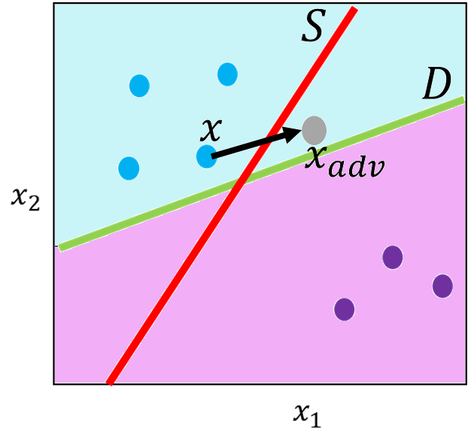
A pure black-box attack is done as follows: Model $S$ is trained on $(X,Y)$ the blue and purple points to create the red decision boundary shown above. A white-box attack is then run on $S$ to generate $x_{adv}.$ Will $x_{adv}$ be misclassified by a second model $D$ with the green decision boundary shown above? Explain why or why not.

Q8. Consider the boundary attack where we are using original sample $O$ with corresponding clean class label $C\left(O\right)=y$. Consider step $k$ of the attack where a random perturbation ${\text{η}}_{k}$ is generated. What will happen in the attack if $C\left({\tilde{O}}^{k-1}+{\text{η}}_{k}\right)=y$? What will happen if $C\left({\tilde{O}}^{k-1}+{\text{η}}_{k}\right)≠y$?

Q9. In terms of the threat model, what is the difference between the query based black-box attacks (like the boundary attack) and the adaptive black-box attack?

Part 3: RayS Black-Box Evasion Attack Code

Background

Many different black-box evasion attacks have been developed in the field of adversarial machine learning. White-box evasion attacks like FGSM, PGD and APGD all share a common threat model. In contrast, black-box attacks like the pure black-box attack and boundary attack have different adversarial threat models, as demonstrated in lecture. Understanding black-box attacks are important as they represent an attacker with less capabilities, which generally translates to a more realistic attack.
One of the successors to the boundary attack, is called the RayS attack. It is not necessary to read the RayS paper but for reference the paper can be found here: https://arxiv.org/abs/2006.12792. In this part of the assignment, you will attack a ResNet-56 trained on CIFAR-10 using RayS.

Step by Step Guide
Step 1: Create a new Python project called “RaySBlackBoxAttack” using the Integrated Development Environment (IDE) of your choice (e.g., Visual Studio, Visual Studio Code, PyCharm).
Step 2: Download the “AttackWrappersRayS.py” file from Brightspace. Also download the ResNet-56 model from Brightspace (this is the same ResNet-56 model used in all other assignments).
Step 3: Run the following code below. Make sure you change the file directory to point to where you have saved the ResNet-56 model:
import torch
import DataManagerPytorchL as DMP
import ResNet
import AttackWrappersRayS

def main():
#Replace the next line with the file path of where you saved the ResNet models
modelDir = "C://Users//Kaleel//Desktop//Machine Learning Security and Privacy//Models//ModelResNet56-Run0.th"
#Define the GPU device we are using
device = torch.device('cuda')
#Parameters for the dataset
batchSize = 64
numClasses = 10
inputImageSize = [1, 3, 32, 32] #Batch size, color channel, height, width
#Create the ResNet model
model = ResNet.resnet56(inputImageSize, numClasses).to(device)
#Next load in the trained weights of the model
checkpoint = torch.load(modelDir)
model.load_state_dict(checkpoint['state_dict'])
#Switch the model into eval model for testing
model = model.eval()
#Load in the dataset
valLoader = DMP.GetCIFAR10Validation(inputImageSize[2], batchSize)
#Check the clean accuracy of the model
cleanAcc = DMP.validateD(valLoader, model, device)
print("CIFAR-10 Clean Val Loader Acc:", cleanAcc)
totalSamplesRequired = 100
correctLoader = DMP.GetCorrectlyIdentifiedSamplesBalanced(model, totalSamplesRequired, valLoader, numClasses)
epsilonMax = 0.031
numSteps = 10
epsilonStep = epsilonMax/numSteps
clipMin = 0.0
clipMax = 1.0
#Run the RayS attack
queryLimit = 10
advLoaderRayS = AttackWrappersRayS.RaySAttack(model, epsilonMax, queryLimit, correctLoader)
advAcc = DMP.validateD(advLoaderRayS, model, device)
print("RayS black-box robustness:", advAcc)

if __name__ == "__main__":
main()

Code Questions

Q10. After running the above code, what robustness does the code report?

Q11. Currently the RayS attack is limited to use 10 queries to try and create each adversarial example. Change the queryLimit to 1000 and re-run the code (the code will now take significantly longer to run). What robustness does the code report? In general, why would the robustness decrease when you increase the query limit in a query based black-box attack?

Q12. Look at lines 8-28 in the file, “AttackWrappersRayS.py”. Is it possible for the RaySAttack() method to return an adversarial example with noise larger than $ε_{max}$? Explain why or why not.

Deliverables
Submit the following two items on Brightspace:
Deliverable #1: A document containing the answers to the questions from parts 1, 2 and 3 of the assignment.
Deliverable #2: A copy of your code in part 3 (the .py files).

